Experiment 1.1

|  |  |  |
| --- | --- | --- |
| **Student Name:** | VIANAYAK GUPTA | **UID:20BCS5696** |
| **Branch:CSE48** | **Section/GroupB** |  |
| **Semester:3** |  | **Date of Performance:** |
| **Subject Name:JAVA** | **Subject Code:** | 20CSP-219 |

1. **Aim/Overview of the practical:**

Write a program to study different types of constructors in java

1. **Task to be done/ Which logistics used:**

These steps can be taken to create the no-arg constructor/Default constructor in a class. It will be invoked at the time of object creation.

1. Create a class.

// class Bike1{

2. Within that class, create a default constructor by using the same name as that of class.

// Bike1(){

3. Write a statement to print a line within that constructor.

//Systemout.println("Bike iscreated");}

4. Create a main method.

// public static void main(String args[]){

5. In the main method, call the default constructor with object creation.

1. **Algorithm/Flowchart (For programming based labs):**
2. **Code:**

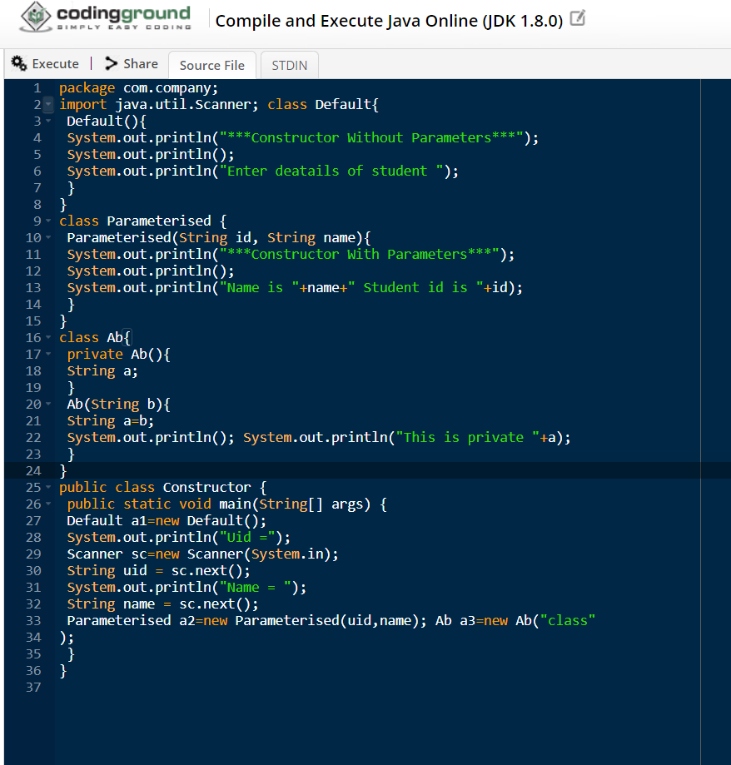

1. **Result/Output/Writing Summary:**

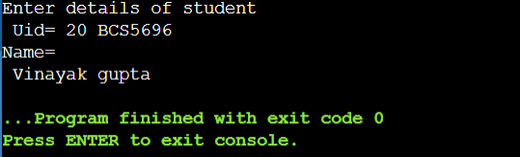

Learning outcomes (What I have learnt): 1.

2.

3.

4.

5.

**Evaluation Grid (To be created as per the SOP and Assessment guidelines by the faculty):**

|  |  |  |  |
| --- | --- | --- | --- |
| Sr. No. | Parameters | Marks Obtained | Maximum Marks |
| 1. |  |  |  |
| 2. |  |  |  |
| 3. |  |  |  |
|  |  |  |  |